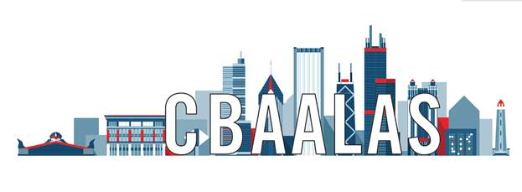
Election Candidate Nomination Form
Submission deadline is November 1, 2023
CBAALAS is seeking candidates to run for elected positions on the CBAALAS Council. Positions on the ballot this year are President-Elect, Treasurer, Secretary, and Council Member(s). All positions are 3-year terms. The President-Elect, Treasurer, and Secretary positions are recommended for those with prior experience on the council. The Council Member position is recommended for individuals who wish to be more involved with the local branch but who may or may not have prior experience on the council.
Eligibility Criteria: Each candidate must be a current member of CBAALAS and be able to attend monthly meetings, of which most are teleconferences. Council meetings are typically held the 2nd Tuesday of each month at 3:30 PM but can change as needed to plan upcoming events.
Election: The election will begin in November. Results of the election will be announced the following January. The candidates elected by the membership will begin their terms when the results are announced and will attend their first council meeting in February.
Directions: Fill out the following contact information and biography. The biography should be a short paragraph introducing yourself to the membership and why you are running for a position on the council. This is what will appear on the election ballot. Return the completed form to Cara Strathmann at CHatten@northshore.org.
Candidate Information
Name: Institution:
Job Title: Email Address:
Mailing Address:
Phone Number:
Are you a current member of CBAALAS? Yes No (Ineligible)
Prior position(s) held on the CBAALAS Council, other local AALAS branches, AALAS, and/or other associations:
What position are you running for? Council Member President-Elect Treasurer Secretary
Biography (will appear on election ballot):

