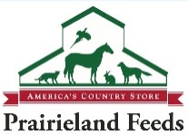
Animal Welfare Award
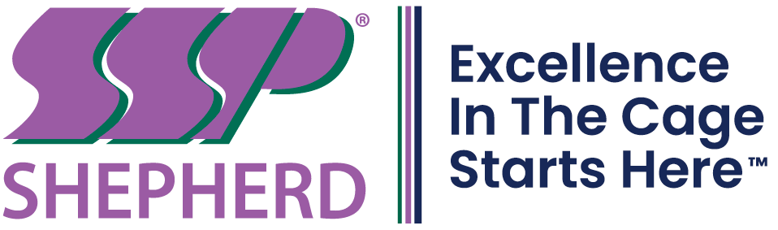
Excellence in Laboratory Animal Welfare
Sponsored by Prairieland Feeds and Shepherd Paper

The Awards Committee is soliciting nominations for the Animal Welfare Award. The award includes a $500 honorarium and plaque. The purpose of the award is to:

- Increase involvement in laboratory animal science and promote enhanced welfare of laboratory animals.
- Stimulate job motivation.
- Enhance personal advancement and/or recognition.
- Recognize an individual who goes above and beyond to enhance and enrich the lives of laboratory animals.

Nominees for this award must meet the following eligibility criteria:

1. Current member of CBAALAS having joined or renewed membership by March 15, 2023.
2. Must not hold a current elected or appointed position on the CBAALAS Council.
3. Must have a minimum of 1 year of experience working in the laboratory animal field.
4. Must be directly involved in the care of laboratory animals.
5. All members who go above and beyond to enhance and enrich the lives of laboratory animals are eligible, including animal care technicians, animal health technicians, enrichment coordinators,
supervisors, managers, veterinarians, etc.
6. Must be nominated by a colleague. Self-nominations are not accepted.

The following items must be received as one nomination packet by no later than December 1, 2023.

1. Completed nomination form.
2. Nomination letter written by the colleague nominating an individual for this award.
3. Nominee’s resume.
4. A minimum of one and a maximum of three letters of support (in addition to
nomination letter).

The CBAALAS Awards Committee will review the nominations and select the winner on the basis of merit. Nominations received after December 1, 2023 will not be eligible for consideration.
Pre-Submission Checklist

Review all your documents carefully and fill in the checklist below to ensure your packet is complete prior to submitting the nomination. This will also help the Awards Committee to confirm they have received all of the documents you intended to include in the packet. Nominations that are received after December 1, 2023 or that do not include all required items will not be accepted.
Required Items:
The nominee meets all eligibility criteria.
The nomination form has been filled out and attached.
Nominee’s resume.
A nomination letter written by the colleague nominating an individual for the award.
A minimum of one and a maximum of three letters of support (in addition to
nomination letter).
How many letters of support are attached? 1 2 3

Have all the authors of letters of support provided their contact information in their letters?
Yes No
If no, please provide the missing contact information here:
Name: | Phone: | Email:
Name: | Phone: | Email:
Name: | Phone: | Email:

Return completed nomination packet by
December 1, 2023 to:

Cara Strathmann
Email: CHatten@northshore.org
If you do not receive a confirmation that your packet was received, please call Cara at 224-364-7979

Please send the nomination form and ALL supporting documents as one package. Whenever possible please scan all documents and email them as one attachment per nominee.

Animal Welfare Award Nomination Form

Name of Nominee: |  | Phone Number:
Institution: | Email Address:
Number of years in the laboratory animal field (Min. 1 year required):
Does nominee hold a current CBAALAS membership? Yes No (Ineligible for award)
Number of years nominee has been a member of CBAALAS:
Number of years nominee has been a member of AALAS:
Highest education level achieved:
Highest AALAS certification achieved:
If nominee is selected for this award is he/she interested in being featured in the Member Spotlight section of the CBAALAS newsletter with a photo and Q&A session?
Yes No
Please describe laboratory animal experience:

Areas of special interest in laboratory animal care:
1)
2)
3)
Special training in laboratory animal care:
1)
2)
3)
Please describe professional animal health activities (e.g. national and/or local committees, etc):

Publications, presentations, awards:

Please describe specific projects, actions, program changes or activities by the nominee that directly relate to the enhancement of environmental enrichment and/or animal welfare:

Nomination submitted by: |  |  | Date:
Email Address: |  |  | Phone Number:

